**CODE** **CHALLENGE**

**Challenge by**

**OLUWADOLAPO ISAAC SALAKO**

**THE CHALLENGE**

Africa is fast becoming a haven for various technological innovations adapted to solve various challenges facing the local environment. The two most popular technology sectors especially in Nigeria are Financial Technology and E-Commerce. So many solutions has been implemented to solve different issues ranging from connecting local farmers to quick, efficient and affordable banking solutions, eliminating the hassle and unnecessary paperwork associated with traditional banking solutions, the top fintechs refers to it as *banking the unbanked.* The same applies to E-commerce, local traders now sell their wares on platforms such as Jiji, Jumia, Konga from the ease of their homes or shops. Jumia for example serves well over 25 states in Nigeria.

To efficiently proffer a digital solution to an existing challenge, I had to speak with entrepreneurs most of whom leverage platforms such as Jumia to sell their products on the biggest challenges they face. The most common challenge had to deal with the difficulty in customers buying the right sizes of clothing and shoes leading to frequent product returns most of which are not in the exact optimal conditions they were purchased at. A certain entrepreneur who sells clothes on platforms such as WhatsApp Business and Facebook Messenger complained

*“Most of my customers end up returning the clothes because it’s not their exact size, especially the youths who prefer closely fitted clothes. I often have to send them another size or just hope the cloth fits them. I really hope there was a way for them to measure their sizes, then send it to me so I won’t have to deal with returned products which often leads to bad PR”*

It was on this premise I took the challenge to propose a digital solution that will help consumers know their exact fit without going through the hassle of measuring their lengths.

**THE SOLUTION**

The solution leverages the capabilities of computer vision tools and frameworks such as

* Python (Programming language of choice)
* OpenCV (Image manipulation library in Python)
* Numpy (Numerical optimization library in Python)
* Mediapipe (Library for pose estimation and landmark detection)

The solution is simple, the consumer takes a full body picture of themselves holding a printed A4 paper containing a reference image that will be used to calibrate the measurements. Any square dark image printed on an A4 paper can be used as the reference image so long the width and height of the square is known. My sample reference image printed on an A4 paper is shown below with a size of 16.5cm X 15.0cm.

16.5cm

15.0 cm

Once the size of the printed reference image is known, the user image is fed into the mediapipe framework which extracts measures all the different landmarks as shown below.

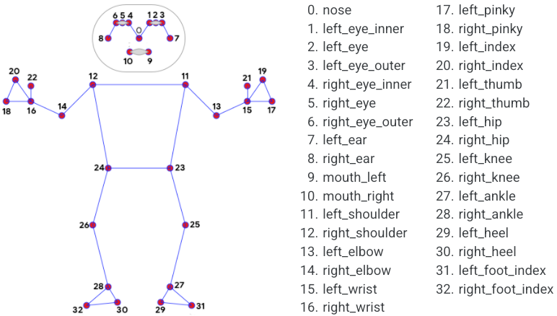

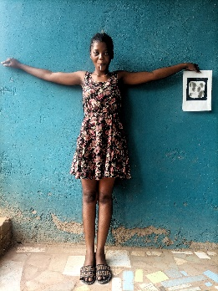The methodology used in implementing the solution is charted below.

Perform pose detection with Mediapipe and extract landmark measurements

Input full body image

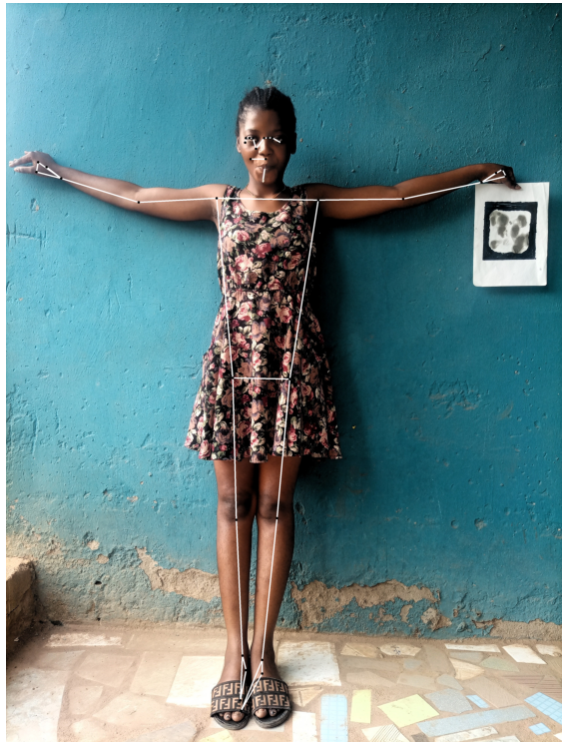

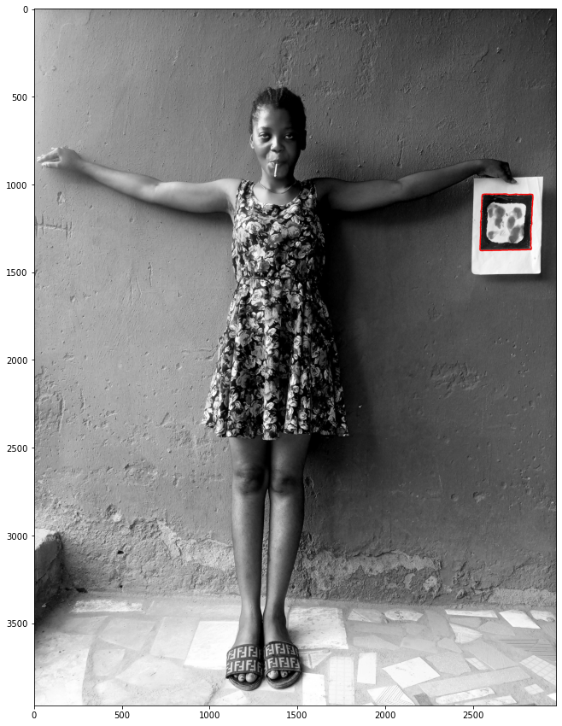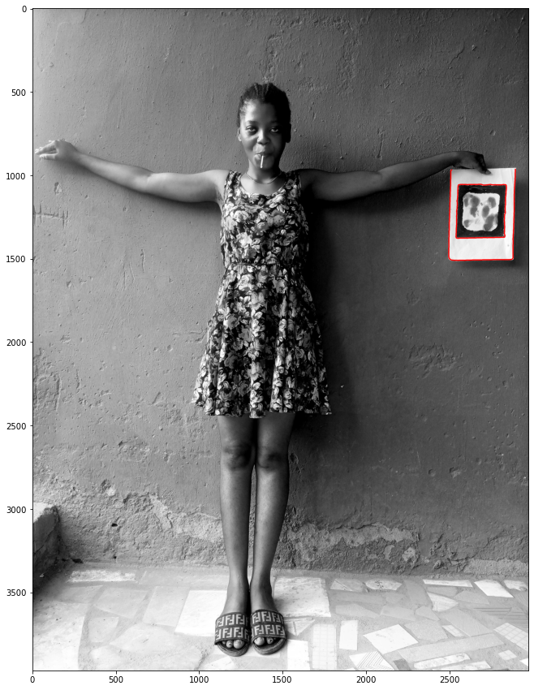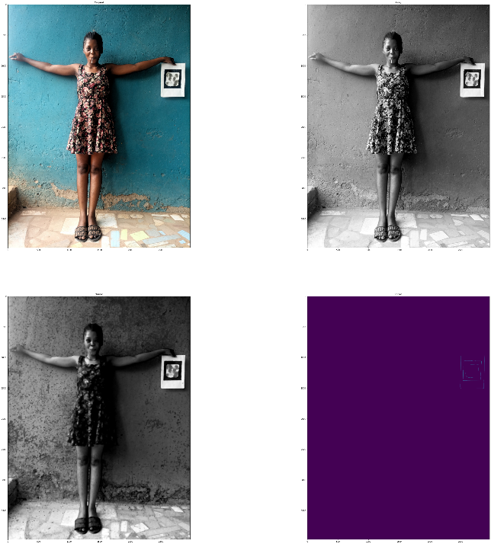

Body measurement with respect to different sizes and fits.

Output

Calibrate measured body landmarks with respect to determined reference size

Extract Contours and retain square only contours and measure contour height and width

Convert image to grayscale, apply erosion and dilation also retrieve edges.

**THE RESULT**

|  |  |  |
| --- | --- | --- |
| **Body Size** | **Measured Size** | **True Size** |
| Shoulder Width | 30cm | 34cm |
| Arm length | 46cm | 50cm |
| Half body length (shoulder to waist) | 49cm | 45cm |
| Full body length (shoulder to ankle) | 128cm | 125cm |
| Trouser length (Hip to ankle) | 79cm | 82cm |

**Average Error: 4cm**